Assignment 5

Q1. Configure HTTP Services with a Server.
1. Assign the HTTP Server the IP address 192.168.10.3 with subnet mask 255.255.255.0.
2. Open Services → HTTP and turn the HTTP service On.
3. Open the PC Web Browser and enter http://192.168.10.3 to verify the website.
4. Access the website using http://www.dream.com after configuring DNS.

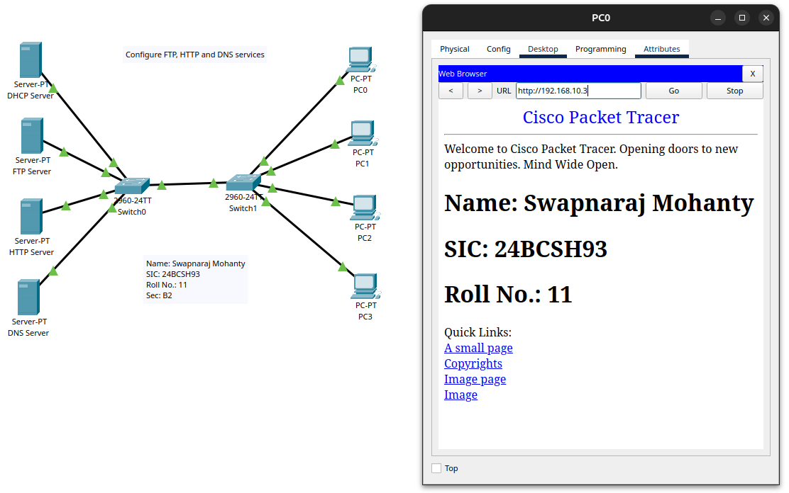

Q2. Configure DNS Services with a Server.
1. Assign the DNS Server the IP address 192.168.10.4 with subnet mask 255.255.255.0.
2. Open Services → DNS and turn the DNS service On.
3. Add an A Record with the following details:
- Name: www.dream.com
- Address: 192.168.10.3
- Open the PC Web Browser and enter http://www.dream.com to verify name resolution and website
access.
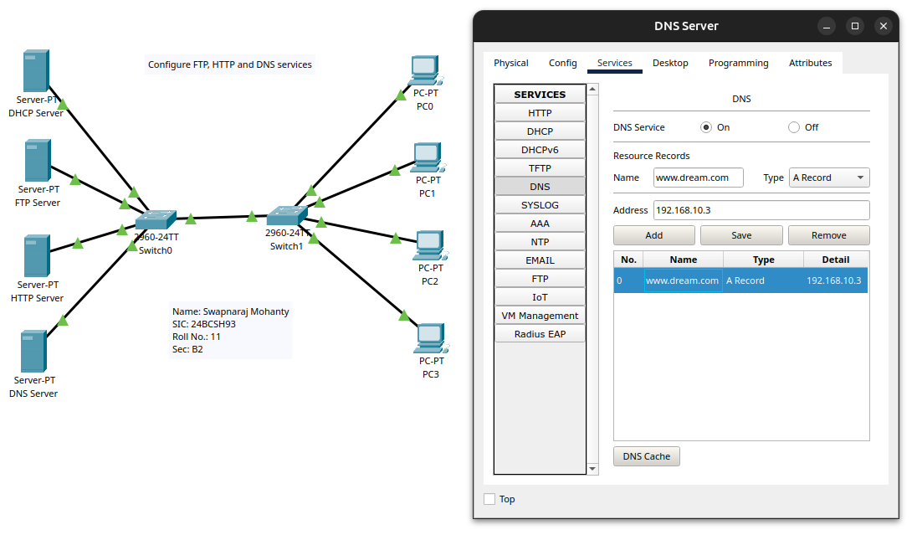
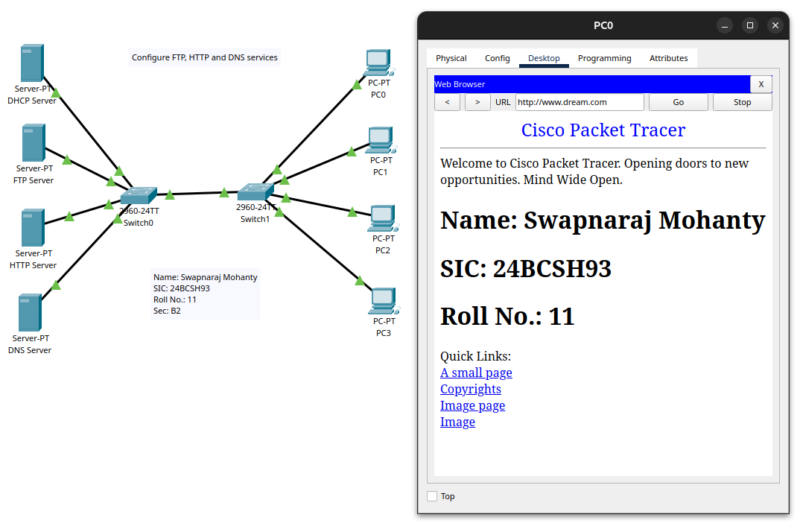
Q3. Configure FTP Services with a Server.
1. Assign the FTP Server the IP address 192.168.10.2 with subnet mask 255.255.255.0.
2. Open Services → FTP and turn the FTP service On.
3. Configure the FTP user accounts and permissions:
- Username: cisco, Password: cisco
- Username: dream, Password: 2503
4. Open the PC Command Prompt and enter:
C:\>ftp 192.168.10.2

5. Log in using the dream account and execute the following commands to test file transfer:
ftp>dir
ftp>get ir800_yocto-1.7.2.tar
ftp>put dream.txt
ftp>quit



